
Symbiosis Institute of Technology, Pune
CSE- Academic Year 2026-27
Java Programming – Lab Batch 2025-29
Lab Assignment No.: 2
Name of Student | Akshit Gawade
PRN No. | 25070122029
Batch | 2025-2029
Class | A1
Academic Year & Semester | Second Year  Semester III
Date of Submission | 4/7/26
Title of Assignment: | Develop a Java application demonstrating the use of default, parameterized, and copy constructors for object initialization and data management.
Problem Statement  Learning Objectives | Problem Statement  Develop a Java application demonstrating the use of default, parameterized, and copy constructors \for object initialization and data management.  Learning Objectives  To understand and implement default, parameterized, and copy constructors for object initialization.
Theory | Constructors are special member functions that are automatically invoked when an object is created.  Java supports default constructors provided by the compiler, parameterized constructors for initializing objects with user-defined values, and copy constructors (implemented manually) for creating duplicate objects. Constructors improve code readability and simplify object initialization  while supporting object-oriented programming principles.
Program Code | 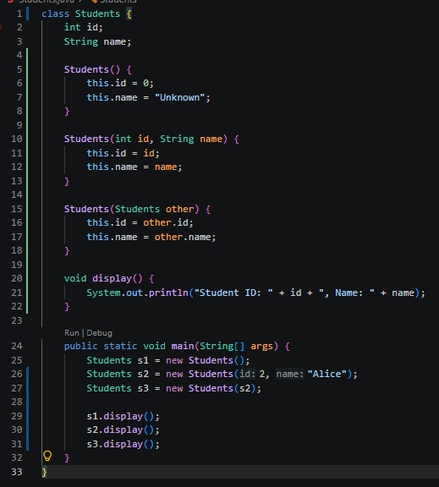
Output Screenshots | 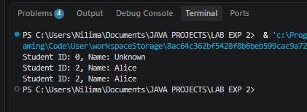
Exercise Qns | - Create a Student class using default and parameterized constructors to initialize student name and roll number.  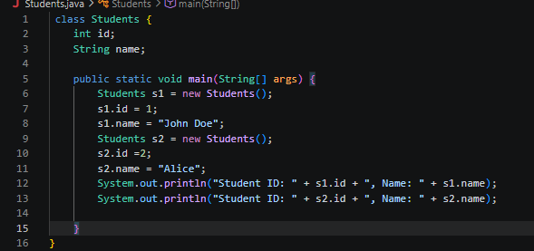  - Develop a Mobile Phone Inventory System using different constructors to initialize mobile details and create duplicate object records.  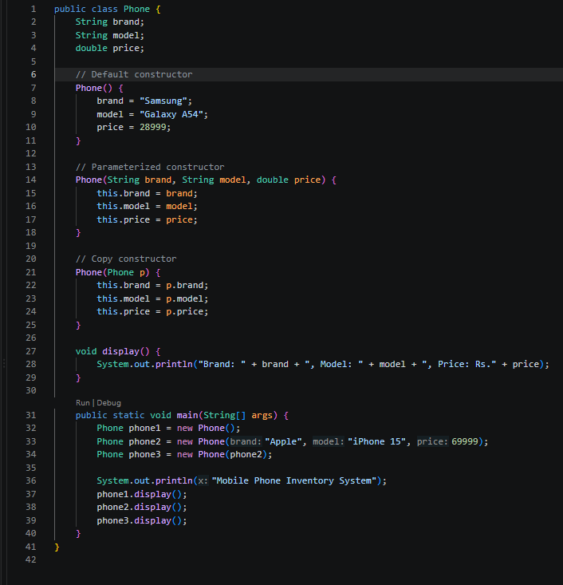
Output Screenshots | Qn 1 completed in main output.  Qn 2:  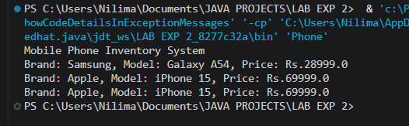
Conclusion | This assignment demonstrated how default, parameterized, and copy constructors enable flexible object initialization and secure data management in Java. The exercises proved that custom copy constructors prevent memory reference conflicts, ensuring independent data replication. Ultimately, mastering these constructor methodologies reinforces core OOP principles, directly improving code reliability and maintainability.

